SECANT METHOD
Find the root of equation $f\left(x\right)=x^{2}-4x-10$ that lies between 1 and 4?
Matlab code
MAIN FUCTION
function main_secant
clc;
clear;
f = @(x) x.^2 - 4*x - 10;

x0 = 1;
x1 = 4;

tol = 1e-6;

maxIter = 100;

root = secant(f, x0, x1, tol, maxIter);

fprintf('Root = %.6f\n', root);

end

function root = secant(f, x0, x1, tol, maxIter)

for i = 1:maxIter

x2 = x1 - (f(x1)*(x1 - x0))/(f(x1)-f(x0));

fprintf('Iteration %d: x = %.6f\n', i, x2);

if abs(x2 - x1) < tol
root = x2;
return;
end

x0 = x1;
x1 = x2;

end

root = x2;

end
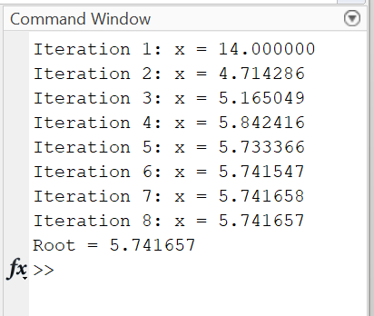
DISPLAY

COMBINED MAIN AND LOCAL FUNCTION
function main_secant
clc;
clear;

f = @(x) x^2 - 4*x - 10;

x0 = 1;
x1 = 4;

tol = 1e-6;
maxIter = 100;

root = secant(f, x0, x1, tol, maxIter);

fprintf('\nRoot = %.6f\n', root);

end

function root = secant(f, x0, x1, tol, maxIter)

for i = 1:maxIter

x2 = x1 - (f(x1)*(x1 - x0))/(f(x1) - f(x0));

fprintf('Iteration %d : x = %.6f\n', i, x2);

if abs(x2 - x1) < tol
root = x2;
return;
end

x0 = x1;
x1 = x2;

end

root = x2;

end
DISPLAY
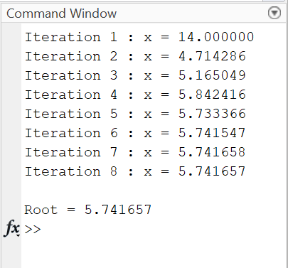

COMBINED MAIN,LOCAL AND NESTED FUNCTION
function main_secant
clc;
clear;
x0 = 1;
x1 = 4;
tol = 1e-6;
maxIter = 100;

root1 = nestedSecant(x0,x1,tol,maxIter);

fprintf('\nRoot from Nested Function = %.6f\n',root1);

root2 = localSecant(x0,x1,tol,maxIter);

fprintf('Root from Local Function = %.6f\n',root2);

function root = nestedSecant(x0,x1,tol,maxIter)

for i = 1:maxIter

f0 = x0^2 - 4*x0 - 10;
f1 = x1^2 - 4*x1 - 10;

x2 = x1 - (f1*(x1-x0))/(f1-f0);

if abs(x2-x1) < tol
root = x2;
return;
end

x0 = x1;
x1 = x2;

end

root = x2;

end

end

function root = localSecant(x0,x1,tol,maxIter)

for i = 1:maxIter

f0 = x0^2 - 4*x0 - 10;
f1 = x1^2 - 4*x1 - 10;

x2 = x1 - (f1*(x1-x0))/(f1-f0);

if abs(x2-x1) < tol
root = x2;
return;
end

x0 = x1;
x1 = x2;

end

root = x2;

end
DISPLAY

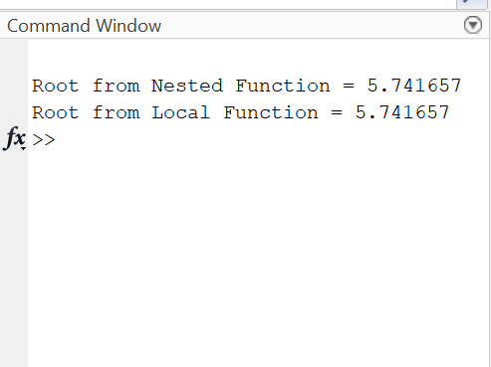

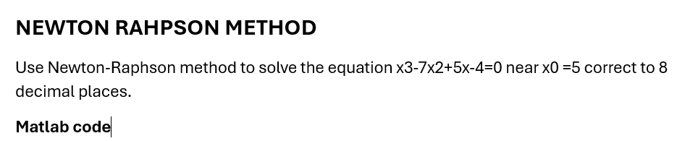
MAIN FUNCTION
function main_newtonraphson
clc;
clear;

x0 = 5;

tol = 1e-8;
maxIter = 100;

for i = 1:maxIter

f = x0^3 - 7*x0^2 + 5*x0 - 4;
df = 3*x0^2 - 14*x0 + 5;

x1 = x0 - f/df;

fprintf('Iteration %d : x = %.8f\n', i, x1);

if abs(x1 - x0) < tol
break;
end

x0 = x1;

end

fprintf('\nRoot = %.8f\n', x1);

end
DISPLAY
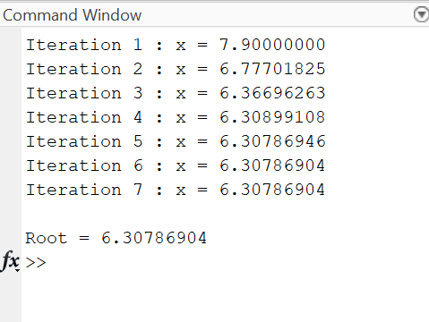

COMBINED MAIN, LOCAL AND NESTED FUNCTION
function main_newton
clc;
clear;

x0 = 5;

tol = 1e-8;
maxIter = 100;

root1 = nestedNewton(x0,tol,maxIter);
fprintf('\nRoot from Nested Function = %.8f\n',root1);

root2 = localNewton(x0,tol,maxIter);
fprintf('Root from Local Function = %.8f\n',root2);

function root = nestedNewton(x0,tol,maxIter)

for i = 1:maxIter

f = x0^3 - 7*x0^2 + 5*x0 - 4;
df = 3*x0^2 - 14*x0 + 5;

x1 = x0 - f/df;

if abs(x1-x0) < tol
root = x1;
return;
end

x0 = x1;

end

root = x1;

end

end

function root = localNewton(x0,tol,maxIter)

for i = 1:maxIter

f = x0^3 - 7*x0^2 + 5*x0 - 4;
df = 3*x0^2 - 14*x0 + 5;

x1 = x0 - f/df;

if abs(x1-x0) < tol
root = x1;
return;
end

x0 = x1;

end

root = x1;

end
DISPLAY
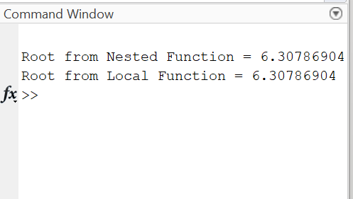

RUNGE KUTTA METHOD
Given the Initial Value Problem (IVP):
$$\frac{d_{y}}{d_{x}}=x+y, y\left(0\right)=1$$
Using the 4th Order Runge-Kutta Method, approximate the value of $y at x = 0.2$ taking a step size $of h = 0.1$
Mathlab code
COMBINED MAIN, LOCAL AND NESTED FUNCTION
function main_rk4
clc;
clear;

x0 = 0;
y0 = 1;
h = 0.1;
xn = 0.2;

y1 = nestedRK4(x0,y0,h,xn);
fprintf('\nValue from Nested Function = %.8f\n',y1);

y2 = localRK4(x0,y0,h,xn);
fprintf('Value from Local Function = %.8f\n',y2);

function y = nestedRK4(x,y,h,xn)

while x < xn

k1 = h*(x + y);
k2 = h*((x+h/2) + (y+k1/2));
k3 = h*((x+h/2) + (y+k2/2));
k4 = h*((x+h) + (y+k3));

y = y + (k1 + 2*k2 + 2*k3 + k4)/6;
x = x + h;

end

end

end

function y = localRK4(x,y,h,xn)

while x < xn

k1 = h*(x + y);
k2 = h*((x+h/2) + (y+k1/2));
k3 = h*((x+h/2) + (y+k2/2));
k4 = h*((x+h) + (y+k3));

y = y + (k1 + 2*k2 + 2*k3 + k4)/6;
x = x + h;

end

end

DISPLAY

